VIETNAM NATIONAL UNIVERSITY HO CHI MINH CITY
HO CHI MINH UNIVERSITY OF TECHNOLOGY



Multidisciplinary Project(CO3107)- Semester 252

WEEK 2 REPORT

Instructor: Trần Huy
Students: Phan Đình Cường- 2310402- CS
Nguyễn Hữu Cầu- 2352129- CS
Lê Bảo Khánh- 2352519- CE
Tán Khánh Phong- 2352911- CS Trần Thụy Thủy Trúc- 2353259- CS

HO CHI MINH CITY, MARCH 2026
Contents
I. Modules Development Description 3
Module 1 : Data Acquistion and Visualization 3
Module 2: Threshold Monitoring and Alerting 3
Module 3: Device Control 3
Module 4: Activity Logging 4
Module 5: Machine Learning Integration 4
II. Hardware Requirements 4
III. General Usecase 5
1. Usecase Diagram 5
2. Description 5
IV. Usecase Details for Each Module 7
Module 1 – Data Acquisition and Visualization 7
Module 2 – Threshold Monitoring and Alerting 8
Module 3 – Device Control 9
Module 4 – Activity Logging 10
Module 5 – Machine Learning Integration 11
V. Non-functional Requirements 12
1. Performance 12
2. Security 12
3. Usability 12
4. Maintainability 12
5. Data Integrity 12
6. Resource 13
VI. UI Design 13
1. Visual Architecture and Layout 14
2. System Dashboard (Central Monitoring) 14
3. Device Fleet Management 14
4. User and Security Interfaces 15
S

Modules Development Description

Module 1 : Data Acquistion and Visualization
This module serves as the foundation of the system, handling the interface between physical sensors and the user interface.
- Sensor Collection: The Yolo:Bit controller manages the input from DHT20 sensors for temperature and humidity, as well as dedicated soil moisture sensors.
- Data Gateway: Collected data is transmitted from the Yolo:Bit to a Python-based IoT Gateway via Serial communication.
- Local Display: Real-time readings and system status updates are rendered immediately on a 16 x 2 LCD screen.
- Remote Monitoring: A centralized Dashboard (available via Web or Mobile) provides a graphical interface for users to monitor the environment from anywhere.

Module 2: Threshold Monitoring and Alerting
This module introduces logic to the data, ensuring the system can identify and react to environmental changes.
- Continuous Verification: The system constantly compares incoming sensor data against pre-defined safety or operational thresholds.
- Irrigation Logic: It specifically monitors soil moisture levels against a minimum threshold to determine if plants require watering.
- Safety Checks: The system monitors for specific conditions, such as high temperature limits, to trigger cooling protocols.

Module 3: Device Control
This module handles the "actuation" phase, where the system interacts back with the physical environment.
- Command Transmission: The IoT Gateway sends control signals back to the hardware layer.
- Actuator Support: The system controls three primary devices: a servo motor, a water pump, and a mini fan.
- Conditional Logic: Device activation can be multi-factor; for example, the mini fan only turns on if the temperature is high and the ultrasonic sensor confirms a human is nearby.

Module 4: Activity Logging
This module focuses on data persistence and historical analysis.
- Database Management: All sensor readings and changes in device states (ON/OFF/Speed) are stored in a persistent database.
- Performance Tracking: This historical record allows users or developers to track system performance and environmental trends over time.

Module 5: Machine Learning Integration
This module adds an intelligent layer to the system for proactive management and advanced UI.
- Gesture Recognition: The system utilizes hand gesture recognition to allow users to trigger specific hardware devices without physical contact.
- Predictive Pre-cooling: Instead of waiting for a threshold to be hit, the system predicts if the room temperature will exceed the limit within the next hour based on current trends.
- Early Intervention: If a future threshold breach is predicted, the system proactively turns on the mini fan early at a lower speed to maintain comfort and efficiency.

Hardware Requirements
Category | Components
Controllers | Yolo:Bit, IoT Gateway (Python-based)
Sensors | DHT20 (Temp/Humidity), Soil Moisture, Ultrasonic
Actuators | Mini Fan, Servo Motor, Water Pump
Display | 16 x 2 LCD Screen

General Usecase

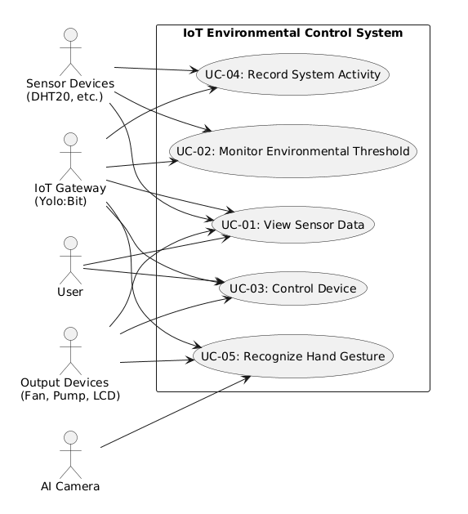
Usecase Diagram

Description
- System Overview
The "IoT Smart Home Control" system is an automated environmental monitoring and control platform designed to collect real-time data from sensors, analyze safety thresholds, and manage peripheral devices via a central controller (IoT Gateway - Yolo:Bit). A key feature of the system is the integration of Artificial Intelligence (AI Camera), which enables touchless device control via hand gestures while persistently storing all system activities for long-term analysis.

- Actors Summary
The system interacts with 5 main actors, including users and hardware entities that provide inputs or receive outputs:
- User: The individual who directly interacts with the system via the web dashboard to monitor environmental parameters and manually control devices.
- Sensor Devices: Input hardware (e.g., DHT20, soil moisture sensors) that continuously measures and transmits raw environmental data.
- IoT Gateway (Yolo:Bit): The central controller acting as a bridge, receiving data from sensors and distributing execution commands to output devices.
- Output Devices: Physical hardware that executes system commands (Mini fan, Water pump) or directly displays information (LCD screen).
- AI Camera: A smart peripheral device responsible for capturing real-time image frames to support the machine learning-based hand gesture recognition module.

- Main Use Cases Summary
The system comprises 5 core functionalities corresponding to the following 5 Use Cases:
- UC-01: View Sensor Data: Allows the user to monitor real-time environmental metrics (temperature, humidity, etc.) through the Web Dashboard and LCD screen.
- UC-02: Monitor Environmental Threshold: The system automatically compares incoming sensor data against predefined thresholds to detect abnormal conditions and determine appropriate corrective actions.
- UC-03: Control Device: Provides the capability to change the operational state of output devices (e.g., turning on/off the fan or water pump) based on manual user commands or automated scenarios.
- UC-04: Record System Activity: Stores all sensor data logs and device state transitions into a database for future lookup, tracking, and performance analysis.
- UC-05: Recognize Hand Gesture: Utilizes an AI model to process camera feeds to recognize user hand gestures, which are then mapped and translated into corresponding device control commands.Usecase Detail for Modules

Usecase Details for Each Module

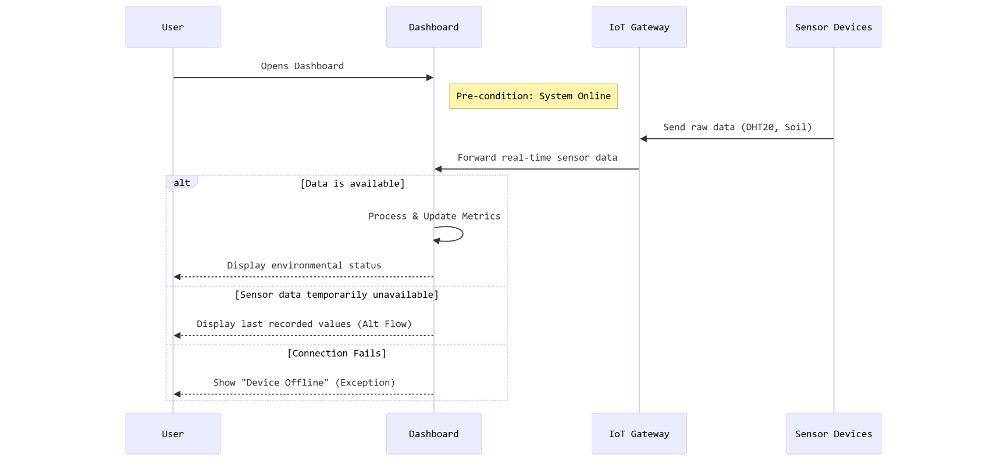
Module 1 – Data Acquisition and Visualization

Description
This module is responsible for collecting environmental data from IoT sensors connected to the Yolo:Bit controller and displaying the information to users through different interfaces such as LCD screens and a web dashboard.

UC-01: View Sensor Data
Use Case ID: UC-01
Use Case Name: View Sensor Data
Actor: User, Sensor Devices, IoT Gateway, Output Devices (LCD)
Trigger: User opens the system dashboard
Pre-condition: System is connected to IoT devices and sensor data is available
Post-condition: The dashboard displays the latest sensor readings and environmental status
Normal Flow: 1. User accesses the dashboard
2. The system receives real-time sensor data from the IoT Gateway
3. The system processes the sensor data
4. The system updates the dashboard metrics
5. User views real-time environmental data
Alternative Flow: If sensor data is temporarily unavailable → the system displays the last recorded values
Exception Flow: If the connection to the IoT Gateway fails → the system shows a “Device Offline” notification

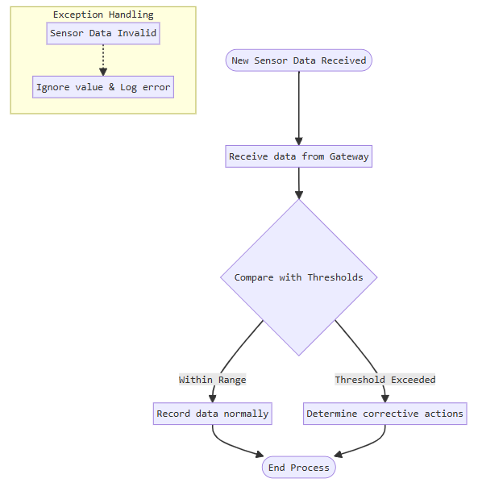
Module 2 – Threshold Monitoring and Alerting

Description
This module monitors sensor values in real time and compares them with predefined thresholds to detect abnormal conditions.

UC-02: Monitor Environmental Threshold
Use Case ID: UC-02
Use Case Name: Monitor Environmental Threshold
Actor: Sensor Devices, IoT Gateway
Trigger: New sensor data is received from IoT Gateway
Pre-condition: Threshold values are predefined in the system configuration
Post-condition: The system determines whether the environment is normal or abnormal
Normal Flow: 1. The system receives sensor data from the gateway
2. The system compares sensor values with predefined thresholds
3. If all values are within normal range → system records the data
4. If a threshold is exceeded → the system determines corrective actions
Alternative Flow: If multiple abnormal values are detected → the system prioritizes the most critical condition
Exception Flow: If sensor data is invalid → the system ignores the value and records an error log

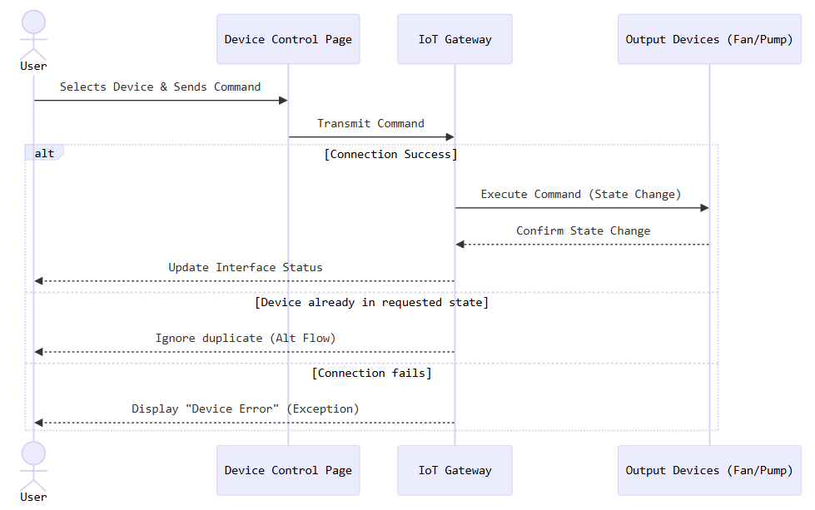
Module 3 – Device Control

Description
This module allows the system to control IoT devices automatically based on sensor data or manually through the dashboard interface.

UC-03: Control Device
Use Case ID: UC-03
Use Case Name: Control Device
Actor: User, IoT Gateway, Output Devices (Mini Fan, Water Pump)
Trigger: User sends a command from the device control interface
Pre-condition: The device is connected and the system is online
Post-condition: The selected device changes its state according to the command
Normal Flow: 1. User navigates to the Device Control page
2. User selects a device (fan, pump)
3. User sends a control command
4. The system transmits the command to the IoT Gateway
5. The IoT Gateway executes the command on the device
Alternative Flow: If the device is already active → the system ignores the duplicate command
Exception Flow: If the device connection fails → the system displays a device error message.

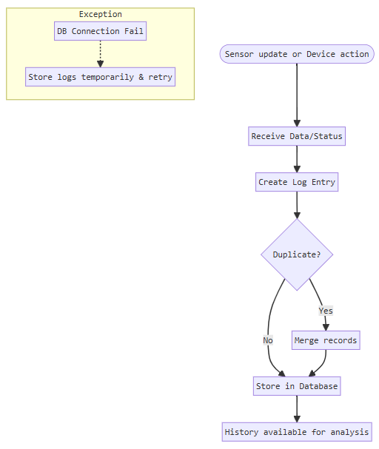
Module 4 – Activity Logging

Description
This module records all sensor activities and device states and stores them in a database to maintain a persistent system history and track performance over time.

UC-04: Record System Activity
Use Case ID: UC-04
Use Case Name: Record System Activity
Actor: IoT Gateway, Sensor Devices
Trigger: Sensor data update or device action occurs
Pre-condition: Database service is running
Post-condition: System activities are stored in the database
Normal Flow: 1. The system receives sensor data or device status updates
2. The system creates a log entry
3. The log entry is stored in the database
4. Historical data becomes available for monitoring and analysis
Alternative Flow: If duplicate logs are detected → the system merges similar records
Exception Flow: If the database connection fails → the system stores logs temporarily and retries later

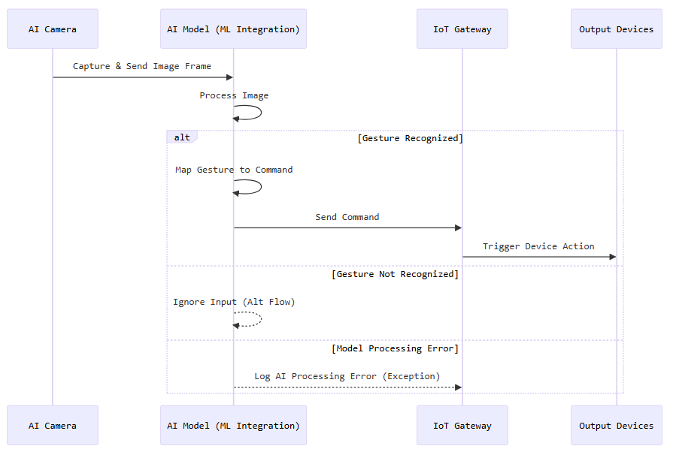
Module 5 – Machine Learning Integration

Description
This module integrates machine learning techniques to analyze environmental data and predict temperature trends to improve system automation. The AI model also supports hand gesture recognition for device control.

UC-05: Recognize Hand Gesture
Use Case ID: UC-05
Use Case Name: Recognize Hand Gesture
Actor: AI Camera, IoT Gateway, Output Devices
Trigger: A hand gesture is detected by the camera
Pre-condition: AI model and camera system are active
Post-condition: The system interprets the gesture and triggers the corresponding device action
Normal Flow: 1. The camera captures an image frame
2. The AI model processes the image
3. The system recognizes the hand gesture
4. The gesture command is mapped to a device action
5. The system sends the command to the IoT Gateway
Alternative Flow: If the gesture is not recognized → the system ignores the input
Exception Flow: If the AI model fails to process the image → the system logs an AI processing error

Non-functional Requirements

Performance
- Sensor data transmission between the Yolo:Bit and IoT gateway must achieve >95% successful message delivery
- Data in the Yolo:Bit controller must be processed within 1 second after being sent from the sensors
- Dashboard updates must display real-time status with a delay of no more than 2 seconds
- Device commands must be executed within 2 seconds after receiving instructions from the IoT gateway
- The AI gesture recognition system must process and respond to gestures within 2 seconds

Security
- Communication between dashboard, cloud server, and APIs must use secure protocols e.g. HTTPS
- Only authenticated users could access configuration settings and device controls

Usability
- Dashboard must provide clear visualization of device status, alerts & notifications

Maintainability
- The system must maintain activity logs for sensor data and device states to help diagnose issues
- Updates to AI models or threshold parameters should be possible without modifying the hardware firmware
- The system must automatically recover from temporary communication failures

Data Integrity
- Sensor readings must be validated before being stored in the database
- The system must prevent duplicate or corrupted log entries in the database
- All activity logs must be stored with timestamps

Resource
- The embedded system must operate within the processing and memory limitations of the Yolo:Bit controller
- AI inference should run efficiently without overloading system resources

UI Design
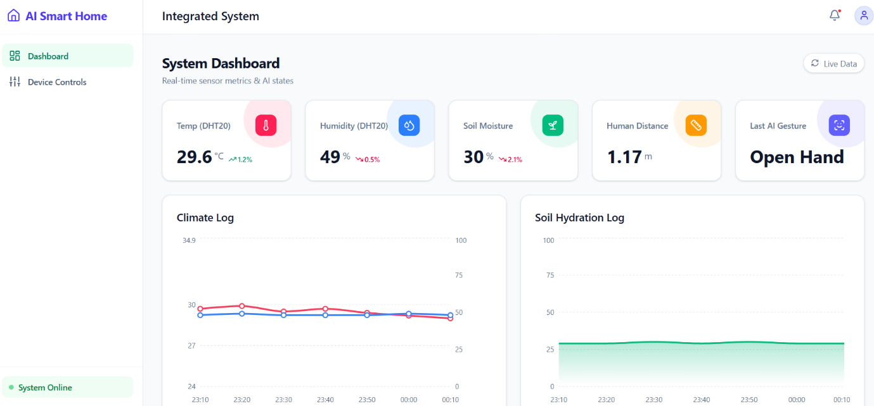
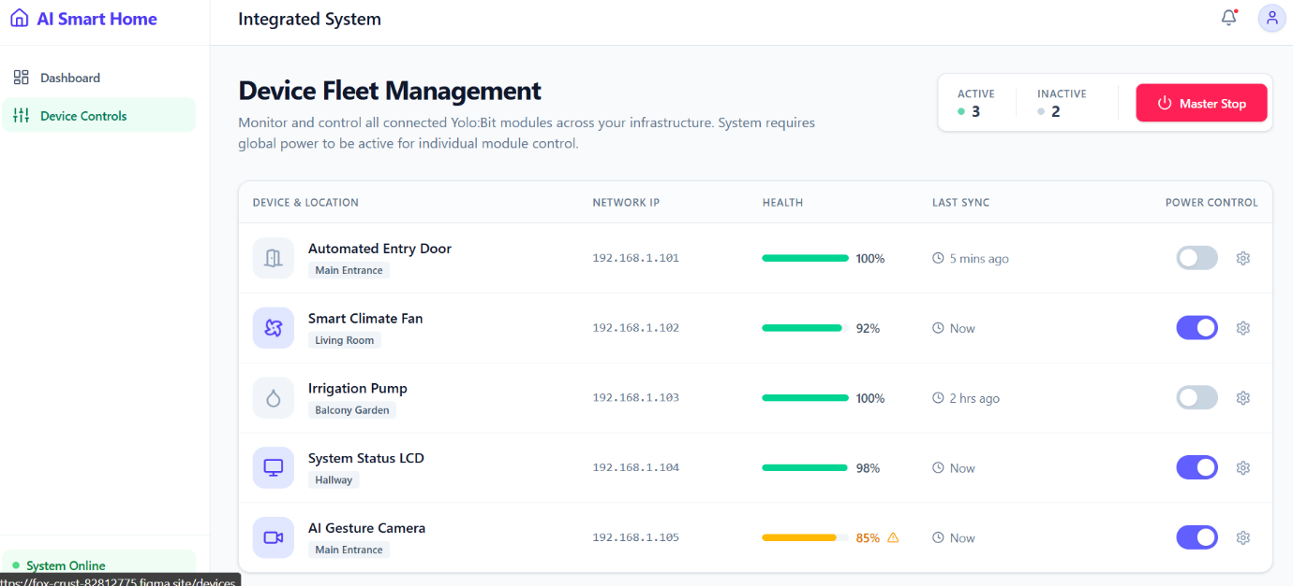

Visual Architecture and Layout
The application utilizes a Single Page Application (SPA) framework to ensure smooth transitions without page reloads. The layout is structured into two primary functional areas:
- Persistent Sidebar: A navigation panel on the left that includes a "System Online" status indicator. It is designed to be responsive, expanding on desktops and collapsing on mobile devices.
- Global Header: Features an "Integrated System" title, a notification bell with a popover menu for alerts (e.g., "High Temperature"), and a user profile dropdown for account settings and logout.

System Dashboard (Central Monitoring)
The Dashboard serves as the command center, providing a holistic view of the home’s environment and AI states.
- Live Metric Cards: Five distinct data streams are displayed via visual cards: Temperature (DHT20), Humidity, Soil Moisture, Human Distance (ultrasonic), and AI Gesture status. These metrics automatically update every 3 seconds.
- Data Visualization: The UI integrates the Recharts library to provide historical context.
  - Climate Log: A line chart tracking temperature and humidity trends.
  - Soil Hydration Log: An area chart visualizing moisture levels over time.
- Sync Status: A "Live Data / Polling" toggle indicates active synchronization with the server.

Device Fleet Management
The "Device Controls" section uses a premium Data Table design to manage connected Yolo:Bit modules.
- Master Control: A prominent "Master Stop" button allows for an emergency shutdown of the entire system.
- Detailed Tracking: The table lists hardware such as the AI Gesture Camera, Smart Fan, and Irrigation Pump. For every device, the UI displays:
  - Network IP and Location (e.g., Main Entrance, Living Room).
  - Health Status: A percentage-based health bar (e.g., 100% or 85% with a warning icon).
  - Last Sync Time: Real-time connectivity status.
- Interactive Toggles: Individual power switches are provided for each device; however, these are automatically disabled if the Master Power is turned off.

User and Security Interfaces
- Authentication Flow: The design includes specialized Login, Register, and Password Recovery pages. A unique UI requirement at registration is the Gateway ID/Address field, which binds the software account to specific physical hardware.
- Settings Hub: A vertical tab-based menu organizes deep configuration options, including notification preferences, security password resets, and an Active Sessions manager to revoke access from unauthorized devices.

